Difference between JDK, JRE and JVM
Understanding the difference between JDK, JRE and JVM is important in Java. We are having brief overview of all three important aspects here.

JVM
JVM (Java Virtual Machine) is an abstract machine. It is a specification that provides runtime environment in which java bytecode can be executed.
JVMs are available for many hardware and software platforms. JVM, JRE and JDK are platform dependent because configuration of each OS differs. But, Java is platform independent.
The JVM performs following main tasks:
- Loads code
- Verifies code
- Executes code
- Provides runtime environment
Basically JVM is just a specification provided by Java Faternity on what a Java Virtual Machine is supposed to do. Hence we have different implementation of JVM by different vendors. For e.g. IBM, Solaris, SUN, Windows all these companies have provided their implementation of JVM for their respective platforms.

JRE
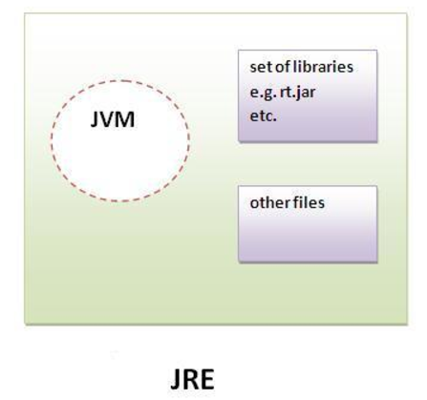
JRE is an acronym for Java Runtime Environment.It is used to provide runtime environment.It is the implementation of JVM. It physically exists. It contains set of libraries + other files that JVM uses at runtime. Implementation of JVMs are also actively released by other companies besides Sun Micro Systems.

The Java Runtime Environment (JRE) provides the libraries, the Java Virtual Machine, and other components to run applets and applications written in the Java programming language. In addition, two key deployment technologies are part of the JRE: Java Plug-in, which enables applets to run in popular browsers; and Java Web Start, which deploys standalone applications over a network. It is also the foundation for the technologies in the Java 2 Platform, Enterprise Edition (J2EE) for enterprise software development and deployment. The JRE does not contain tools and utilities such as compilers or debuggers for developing applets and applications

JDK
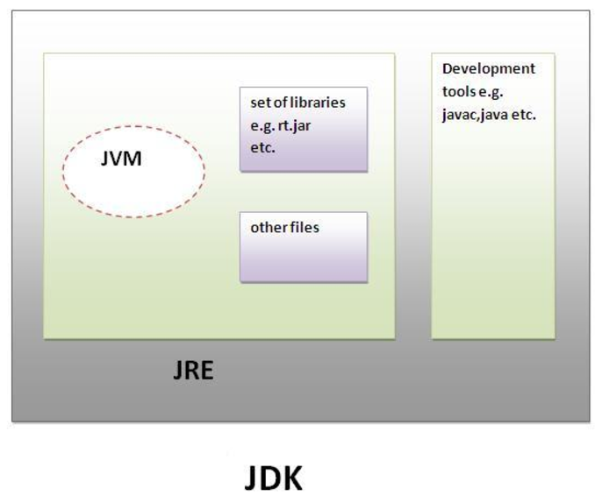
JDK is an acronym for Java Development Kit.It physically exists.It contains JRE + development tools. The JDK is a superset of the JRE, and contains everything that is in the JRE, plus tools such as the compilers and debuggers necessary for developing applets and applications.

Important Pointers
- JVM is just a specification, it doesn't physically exists.
- For executing a Java program, JRE is sufficient enough but we cannot do development with only JRE. JRE physically exists.
- For Java Development, we need JDK [ JRE + Development tools ]. JDK physically exists.
- Assuming tomorrow I create a new operating system I cannot execute Java Program right away because i will need a JRE installed on my OS to run Java Program, as I have created new OS there are two scenario's where in I design my OS to support existing version of JRE avalaible or I have to design a new JRE basically implemenentation of JVM for my OS
- Hence when we say Java is platform dependent it doesn't mean we can run it on any machine without JDK or JRE, any particular OS on which we need to run Java Progarm should have JDK or JRE installed on it.
- When we say Java is platform independent it means when I run a Java Program on any implementation of JVM whether it is provided by IBM, Microsoft, or Oracle, my Java Progarm will exhibit consistent behaviour on all platforms

Lets Dive more into JVM now
JVM is:
- A specification where working of Java Virtual Machine is specified. But implementation provider is independent to choose the algorithm. Its implementation has been provided by Sun and other companies.
- An implementation Its implementation is known as JRE (Java Runtime Environment).
- Runtime Instance Whenever you write java command on the command prompt to run the java class, an instance of JVM is created.
The JVM performs following operation:
- Loads code
- Verifies code
- Executes code
- Provides runtime environment

JVM provides definitions for the:
- Memory area
- Class file format
- Register set
- Garbage-collected heap
- Fatal error reporting etc.

Internal Architecture of JVM

1) Classloader
Classloader is a subsystem of JVM that is used to load class files.

2) Class(Method) Area
Class(Method) Area stores per-class structures such as the runtime constant pool, field and method data, the code for methods.

3) Heap
It is the runtime data area in which objects are allocated.

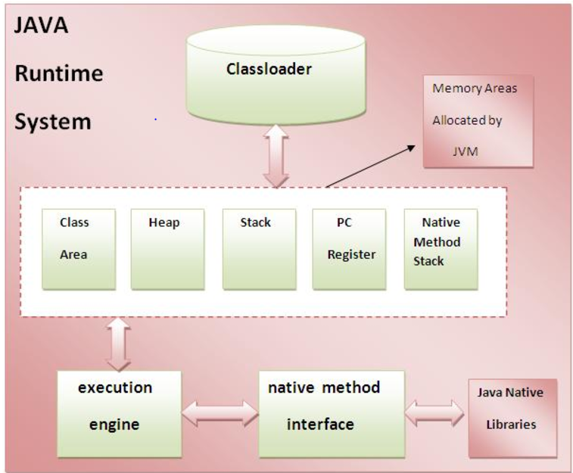
4) Stack
Java Stack stores frames.It holds local variables and partial results, and plays a part in method invocation and return. Each thread has a private JVM stack, created at the same time as thread. A new frame is created each time a method is invoked. A frame is destroyed when its method invocation completes.

5) Program Counter Register
PC (program counter) register. It contains the address of the Java virtual machine instruction currently being executed.

6) Native Method Stack
It contains all the native methods used in the application.

7) Execution Engine
1) A virtual processor
2) Interpreter: Read bytecode stream then execute the instructions.
3) Just-In-Time(JIT) compiler: It is used to improve the performance.JIT compiles parts of the byte code that have similar functionality at the same time, and hence reduces the amount of time needed for compilation.Here the term ?compiler? refers to a translator from the instruction set of a Java virtual machine (JVM) to the instruction set of a specific CPU.

